DEERWALK INSTITUTE OF TECHNOLOGY
Tribhuvan University
Faculties of Computer Science

Bachelors of Science in Computer Science and Information
Technology
(BSc. CSIT)
Course: Numerical Method (CSC-207)
Class of 2027/Semester: III
A Lab Report On:
Interpolation and Regression
Submitted to:
Ganesh Thapa
Faculty, Department of Computer Science
Submitted by:
Name: Shaurav Bhandari
Roll No: 1333

LAB 2
TITLE: Interpolation and Regression

OBJECTIVES:
To study different interpolation methods used to find the value for independent variable using provided reference data.
THEORY:
- Interpolation:
  - It is a numerical method that is used to estimate the value of a function for an intermediate value of the independent variable, given a set of discrete Data points.
- Regression:
  - Regression is a numerical method used to model and analyze relationships between dependent and independent variables.
- Newton’s Forward Interpolation:
  - This method is used when the values of the independent variables x are equally spaced. It uses finite differences to calculate the value of the dependent variable for a given x.
  - The formula for the interpolation polynomial is:

where,

h: spacing between the consecutive x values.
are forward differences.
The forward Difference table for this method is as follows:
x | y
 |  |  |  | Etc.
- Lagrange’s Interpolation:
  - This method is used when the x-values are not equally spaced. It constructs a polynomial that passes through all the given points.
  - The formula for the interpolation polynomial is

  - where:
    - = Lagrange Basis Polynomials
    - : given data points.
- Newton’s Divided Difference Interpolation:
  - It is a more general method that can handle both equally and unequally spaced x values. It uses divided differences to construct the interpolation polynomial./
  - The interpolation polynomial is given by:

  - where are divided differences computed recursively as:
  - ,
  - The divided difference table is constructed as follows:
X | Y |  |  | Etc.

PRACTICAL IMPLEMENTATION

TASK 1: NEWTON'S FORWARD INTERPOLATION METHOD

ALGORITHM:
Input: n, x[20], y[20], xp
Output: yp
- Declare variables n, i, j as integer.
- Declare variables x[20] and y[20] to store the x and y values.
- Declare a 2D array diff[20][20] to store the forward differences.
- Declare variables xp, p, h, nr, dr, and yp as floating point numbers for calculations.

- Read n, x, y
- Read xp

- Calculate Differences:
  - Calculate h = x[1] – x[0] as the difference between the second and first x values.
  - For i from 0 to n-1:
    - Calculate diff[i][1] as y[i+1] - y[i].
  - For j from 2 to n:
For i from 0 to n-j:
- Calculate diff[i][j] as diff[i+1][j-1] - diff[i][j-1].

- Calculate Interpolation:
- Calculate p as (xp - x[0]) / h.
- Initialize yp with y[0].
- For k from 1 to n-1:
- Calculate nr *= (p - k + 1).
  - Calculate dr *= k.
  - Update yp += (nr / dr) * diff[i][k].

- Output Result:
Print the interpolated value yp for the given xp..

SOURCE CODE:

OUTPUT:
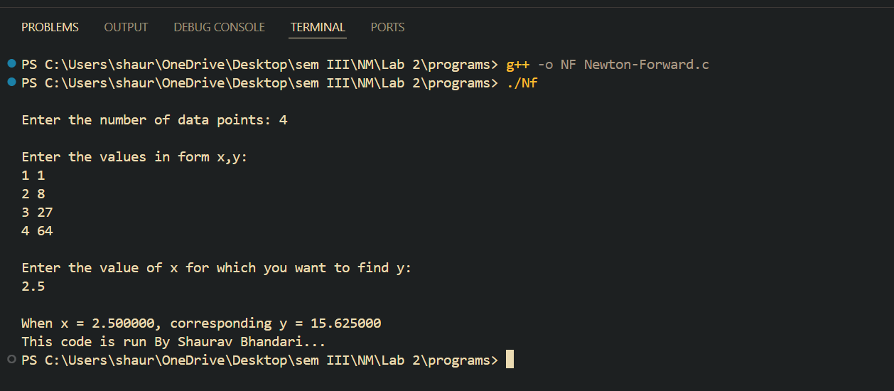

TASK 2: LAGRANGE'S INTERPOLATION METHOD

ALGORITHM:
Input: n, x[100], y[100], xp
Output: yp
- Declare arrays x[100] and y[100] to store the x and y values.
- Declare variables xp and yp for calculations.
- Declare variables n, i, j, and p.
- Read n, x, y
- Read xp
6. Interpolate using Lagrange's method:
a. For i from 1 to n:
i. Initialize p to 1.
ii. For j from 1 to n:
- If i is not equal to j, calculate p *= (xp - x[j]) / (x[i] - x[j]).
iii. Update yp += p * y[i].

7. Output Result:
- Print the interpolated value yp for the given xp.

SOURCE CODE:

OUTPUT:

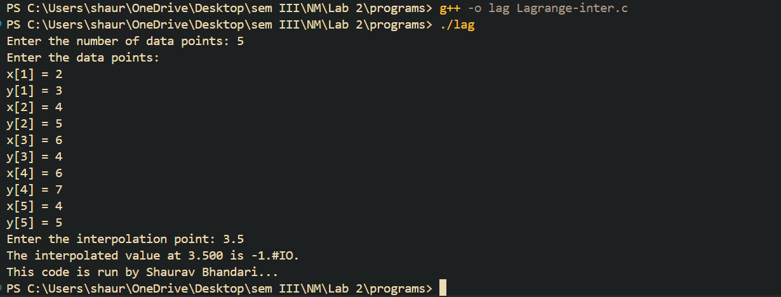
TASK 3: NEWTON'S DIVIDED DIFFERENCE INTERPOLATION

ALGORITHM:
Algorithm Newton Interpolation:
Input: n, x[10], y[10], k
Output: f

1. Initialize variables:
- Declare arrays x[10], y[10], and p[10] to store x values, y values, and divided differences.
- Declare variables k, f, n, f1, f2, i, j = 1;
2. Read n, x, y
3. Read k
4. Calculate Divided Differences:
a. Use a do-while loop until n becomes 1:
i. For i from 1 to n-1:
- Calculate p[i] = (y[i+1] - y[i]) / (x[i+j] - x[i]).
- Update y[i] = p[i].
ii. Initialize f1 = 1.
iii. For i from 1 to j:
- Calculate f1 *= (k - x[i]).
iv. Update f2 += y[1] * f1.
v. Decrement n and increment j.
5. Calculate Interpolation:
- Update f += f2.
6. Output Result:
- Print the interpolated value f for the given k.

SOURCE CODE:

OUTPUT:
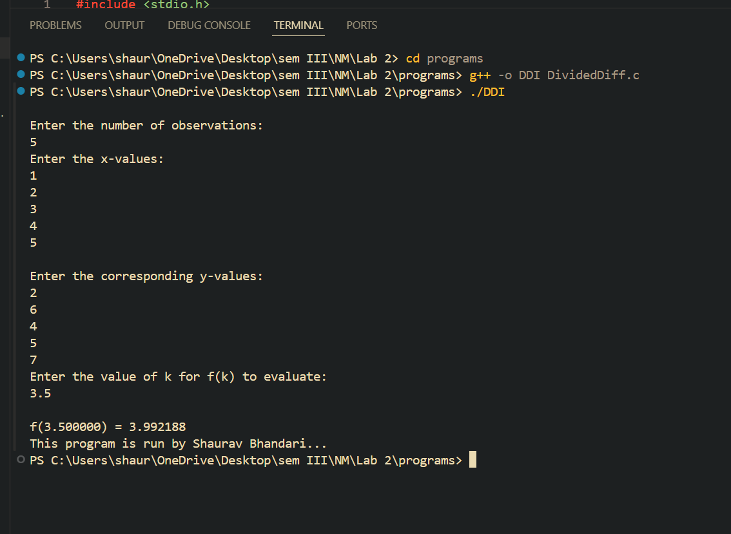

TASK 4: LINEAR REGRESSION
Solving the non- linear equation x³ - 2x – 5 correct upto 3 decimal places using secant method.

ALGORITHM:
- Start
- Initialize variables: n,i as integer
- Initialize variable x[20],y[20], sumX = 0, sumX2 = 0, sumY = 0, sumXY = 0, a, b as floating point number.
4. Read Number of Data (n)
5. For i=1 to n:
Read Xi and Yi
Next i

6. Calculate Required Sum
For i=1 to n:
sumX = sumX + Xi
sumX2 = sumX2 + Xi * Xi
sumY = sumY + Yi
sumXY = sumXY + Xi * Yi
Next i
7. Calculate Required Constant a and b of y = a + bx:
b = (n * sumXY - sumX * sumY)/(n*sumX2 - sumX * sumX)
a = (sumY - b*sumX)/n
8. Display value of a and b
9. Print the equation of the best fit line: y = a + bx.

SOURCE CODE:

OUTPUT:

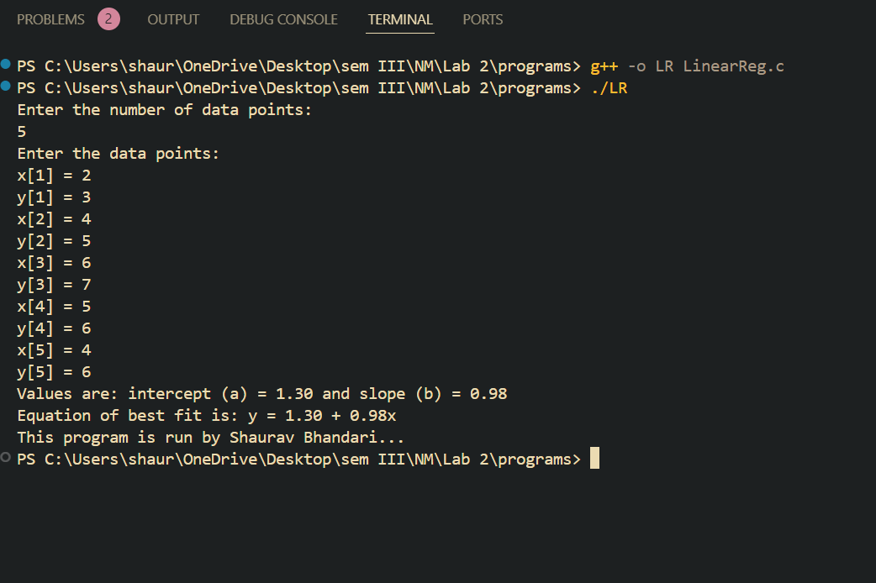

CONCLUSION:
Hence, we implemented the various methods of interpolation and regression in the C Programming Language. Different methods like Newton’s Forward Interpolation, Lagrange’s Interpolation, Divided Difference Interpolation and Linear Regression, were utilized to calculate intermediate values for given datasets, demonstrating their utility for equally and unequally spaced data. This exercise helped to deepen our understanding of numerical methods, while also enhancing our programming skills simultaneously.

